|  |  |  |  |  |  |  |  |  |
| --- | --- | --- | --- | --- | --- | --- | --- | --- |
| |  | | --- | | Benro tripod - T980 | | Product image thumb |  |  |  |  |  | | --- | --- | --- | --- | | Product image thumb | Product image thumb | Product image thumb |  | |  | **Specifications:**  **Material:** aluminum alloy  **Maximum height:** 169 cm  **Minimum height:** 67.5 cm  **Folded length:** 53.3cm  **Price: 50$** |

**Overview:**

**Benro tripod - T980 | Audio FOTOLAB**

The Benro - T980 tripod has a sturdy aluminum alloy design with a load capacity of up to 5kg. Users can flexibly control the tripod, rotate the camera in many directions easily, create impressive photos from many different angles or unique vertical photo frames. In addition, the base of the Benro - T980 is also covered with anti-slip rubber to help the tripod stand firmly on any terrain.

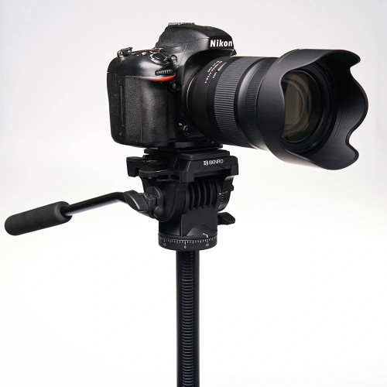

**Benro tripod - T980**

The Benro - T980 tripod has a sturdy aluminum alloy design with a load capacity of up to 5kg. Users can adjust the camera rotation up and down, left and right or horizontally 90 degrees to capture unique horizontal or vertical photo frames as desired.

The Benro - T980 tripod has a sturdy aluminum alloy design with a load capacity of up to 5kg.

The tripod design is not only compatible with mirrorless cameras and DSLR cameras, but you can also combine it with accessories to use with your smartphone. The base of the tripod is covered with rubber, helping the Benro - T980 stand firmly on different surfaces.